

WU ITIO Cloud Enablement TEC Pune



Infrastructure as a code – Developer Guide

**Document Management**

**Version History**

|  |  |  |
| --- | --- | --- |
| **Version** | **Contributor** | **Description** |
|  |  |  |
| **0.1** | **Navneet Rathi** | **Infrastructure as a code** |
|  |  |  |
|  |  |  |
|  |  |  |

Infrastructure as a code

TABLE OF CONTENTS

1. Infrastructure as a code
2. CloudFormation
3. Access git Repository
4. **Infrastructure as a code**

IaC is a key DevOps practice and is used in conjunction with continuous delivery. **Infrastructure** **as** **Code** evolved to solve the problem of environment drift in the release pipeline.

1. Cloud Formation

In Aws environment we use CloudFormation for infra as a code all the cloud formation templates regarding infra provisioning are stored in a gitlab repository on WU intranet network on URL <https://gitlab.wuintranet.net/309762/CF-template.git>

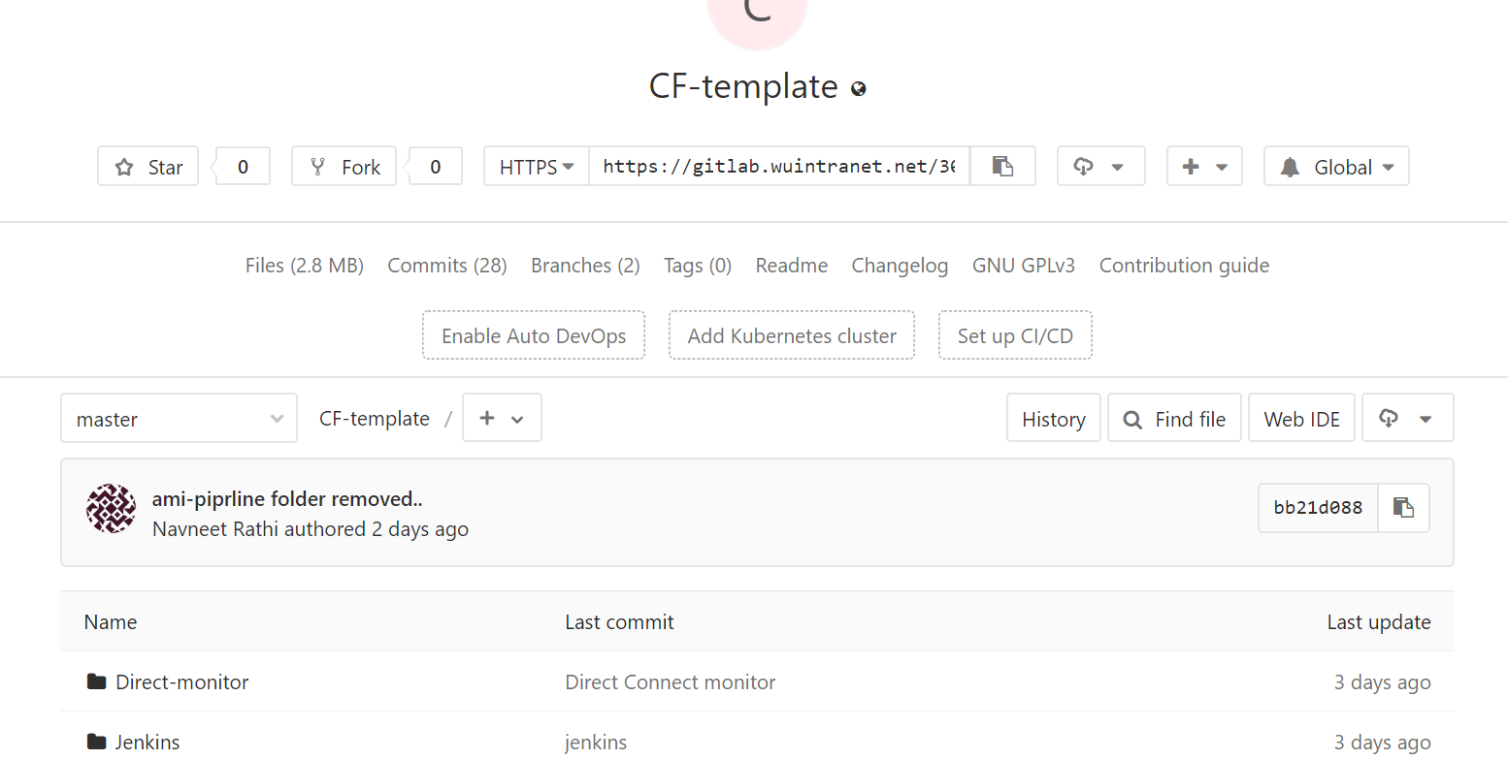

1. How to Access the Gitlab repository

For accessing the repository you need to raise an Ipass request same as any other access.

IPass 🡪 Add or remove access 🡪 click on “Active directory domain HQINTL1” 🡪 Add access 🡪review 🡪 complete form 🡪 modify existing account 🡪 and search for “**App-git-user**”

And raise access

Once you gain access to GitLab you can fork the repo if required

You can download the repository from URL.